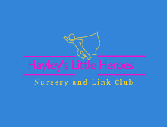
Sun Protection Policy
Hayley’s Little Heroes will do everything we can, working in partnership with parents to ensure that your child is protected from the sun. For this we will need you to provide us with the following.
- Suncream suitable for your child (high factor)
- Sun Hat (preferably a legionnaires hat to protect the neck)
- A thin top/cardigan/t-shirt with long sleeves.
Hayley’s Little Heroes will ensure that your child uses the sun cream that you have provided and wears that hat.
We will also avoid spending prolonged periods of time outdoors during the hottest part of the day, and when out will try and protect your child by finding shady areas and using sunshades on any push chairs. We will encourage your child to drink water regularly to prevent dehydration. We will require you to sign a form to give permission for staff at Hayley’s Little Heroes to apply suncream. This, can be found on our contracts when you complete them before your child starts.
We will have nursery sun cream on site should your provided cream run out. We will inform you if this is the case so that you can replace it.

Should you have any concerns regarding your child’s health and safety, then please don’t hesitate to contact a senior member of staff immediately.

Checked 1/7/25
By Hayley Ashorobi
Review Date – July 26

